Remote Sensing Image Scene Classification Meets Deep Learning: Challenges, Methods, Benchmarks, and Opportunities

In this paper author is not introducing any new algorithm but giving review on existing algorithms for Remote Satellite scene classification. Images which capture from Remote satellite must be classify accurately but due to common region mapping in images algorithms may get confuse and classify incorrectly. In propose paper author is giving review and challenges on various deep learning scene classification algorithms called VGG16, Auto Encoder-decoder and GAN (generative adversarial network).

All algorithms face challenges and get confuse to classify scenes images which has common region. In propose paper author saying VGG19 is giving best result and author evaluate all algorithms performance by using various dataset such as NWPU, UC Merced and many more.

Training all algorithms using various dataset may take days of time so we have trained VGG19 with NWPU dataset to classify 19 different remote scenes images. In below screen showing dataset used to train VGG19 algorithm

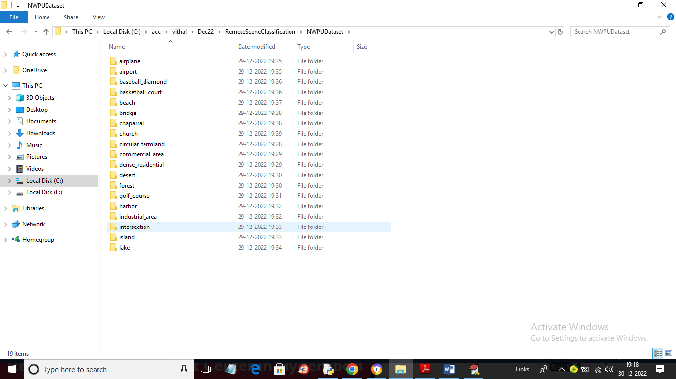

In above screen we have 19 folders and each folder contains various scenes images and just go inside any folder to view images like below screen

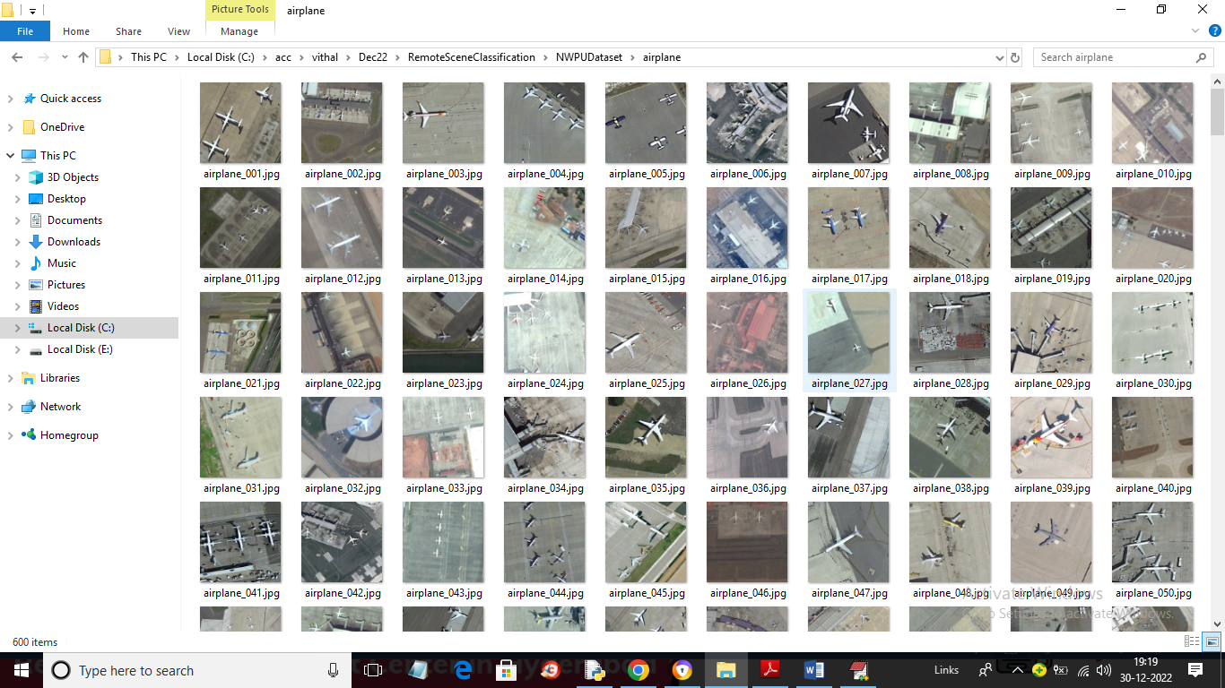

So by using above images we will train VGG19 and then evaluate performance in terms of accuracy and confusion matrix.

To implement this project we have designed following modules

1. Upload NWPU Satellite Scenes Dataset: using this module we will upload dataset to application
2. Preprocess Dataset: using this module we will read all images and then resize all images to equal size and then normalize and shuffle images and then split dataset into train and test where application use 80% dataset images for training and 20% for testing
3. Train VGG19 Algorithm: using this module we will feed 80% images as input to VGG19 to trained a model and this model will be applied on 20% test images to calculate prediction accuracy
4. VGG19 Training Graph: using this module we will plot VGG19 train and test graph
5. Remote Scenes Classification: using this module we will upload Remote Satellite test image and then VGG will predict or classify scenes from that image

SCREEN SHOTS

To run project double click on ‘run.bat’ file to get below screen

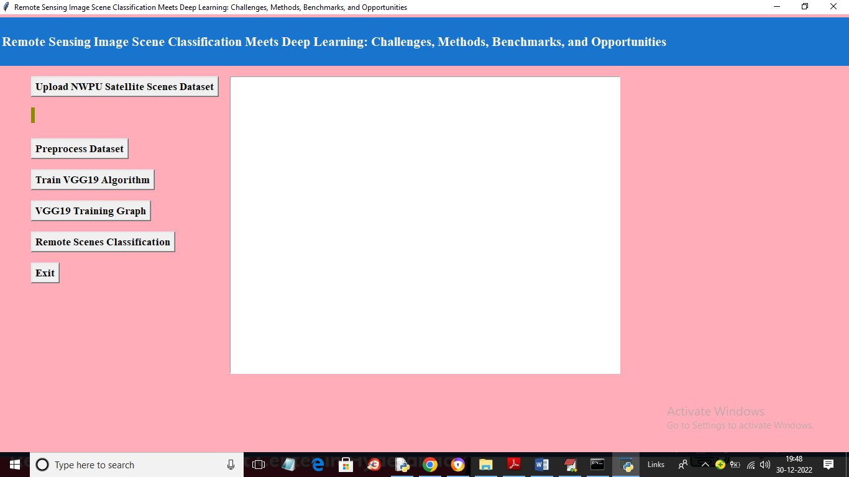

In above screen click on ‘Upload NWPU Satellite Scenes Dataset’ button to upload dataset and get below output

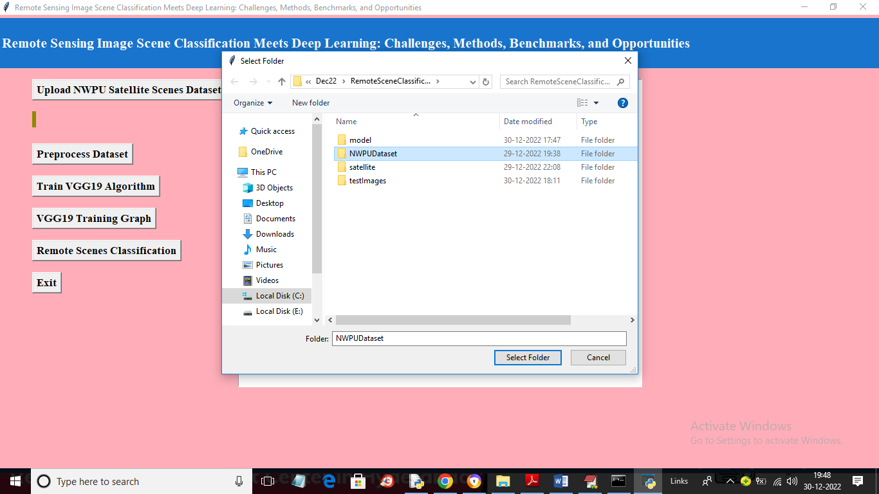

In above screen selecting and uploading entire ‘NWPU’ dataset folder and then click on ‘Select Folder’ button to load dataset and get below output

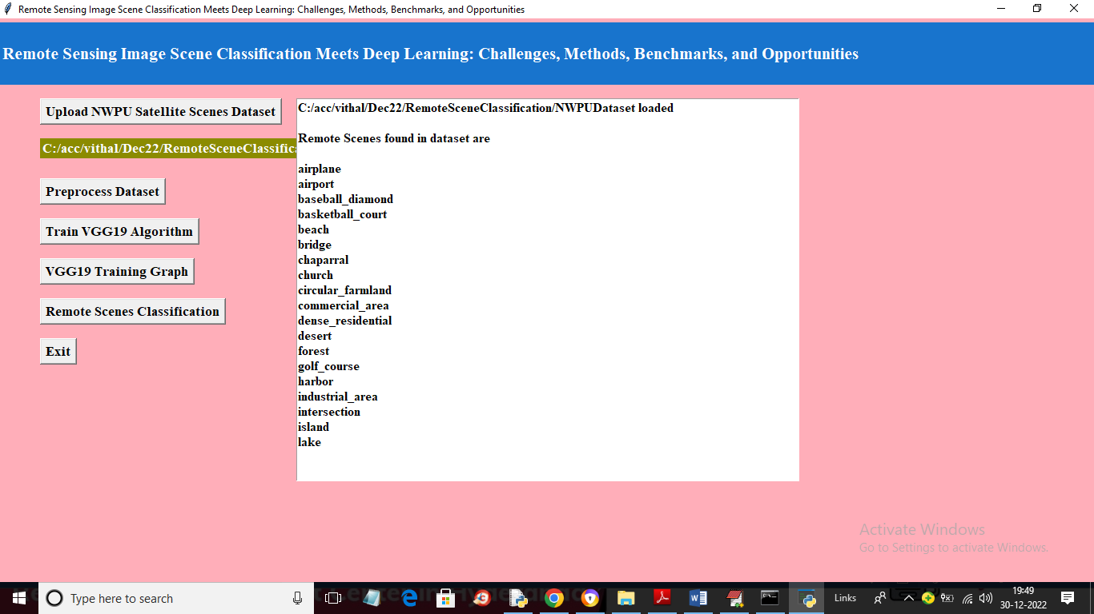

In above screen dataset loaded and we can see the names of scenes available in dataset and now click on ‘Preprocess Dataset’ button to process all images and get below output

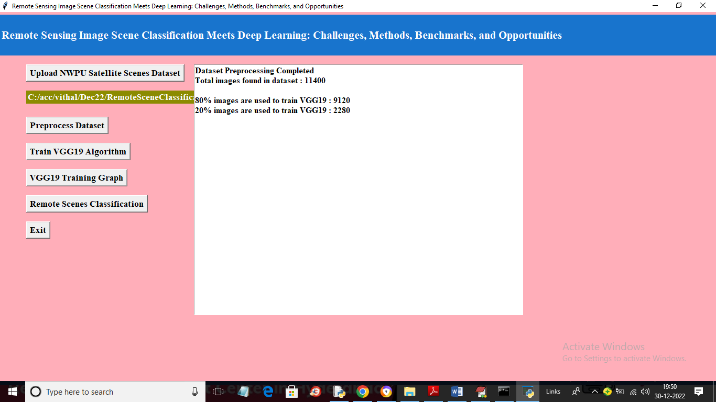

In above screen all images are processed and then application spilt them into train and test where we can see total images, training and testing images size and now click on ‘TrainVGG19 Algorithm’ button to train VGG on given image and get evaluate on test images to calculate its prediction accuracy

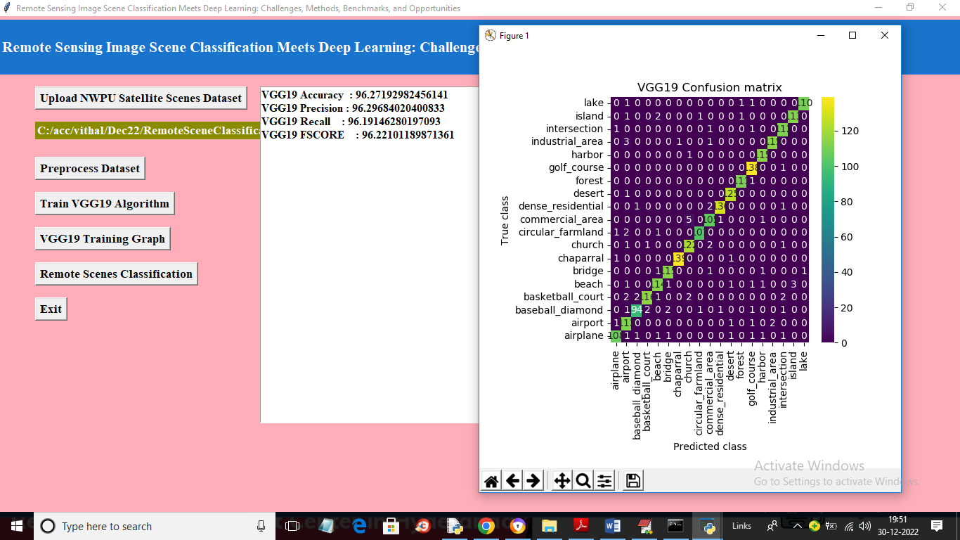

In above screen with VGG19 we got 96% accuracy and in confusion matrix graph x-axis represents Predicted Labels and y-axis represents True labels and the count in diagnol in different colours represents correct prediction count and all blue colour boxes represents incorrect prediction count which are very few and now close above graph and then click on ‘VGG19 Training Graph’ button to get below graph

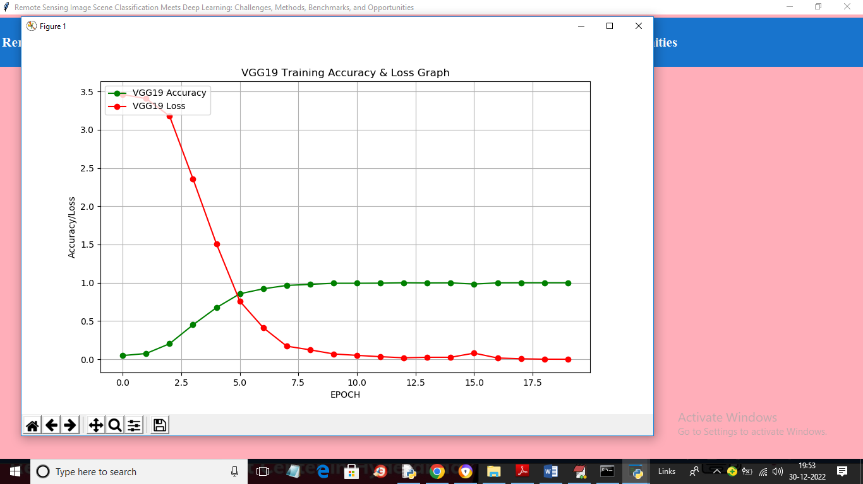

In above graph x-axis represents training epoch and y-axis represents training accuracy and loss. Green line represents accuracy and red line represents loss and with each increasing epoch accuracy got increase and reached closer to 1 and loss got decreased and reached closer to 0. Now close above graph and then click on ‘Remote Scenes Classification’ button to upload image and classify scenes

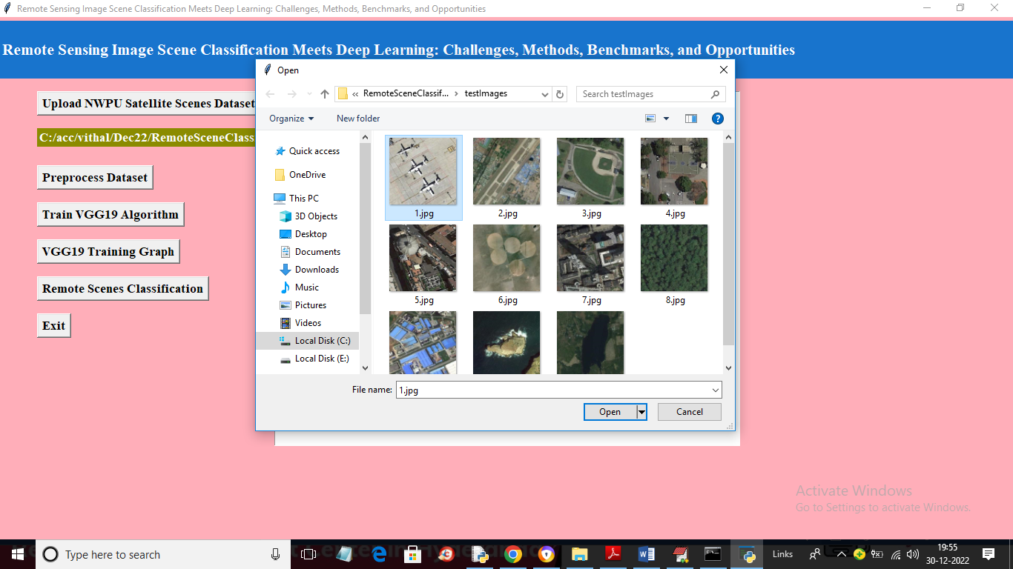

In above screen selecting and uploading ‘1.jpg’ and then click on ‘Open’ button to load image and get classification from VGG19

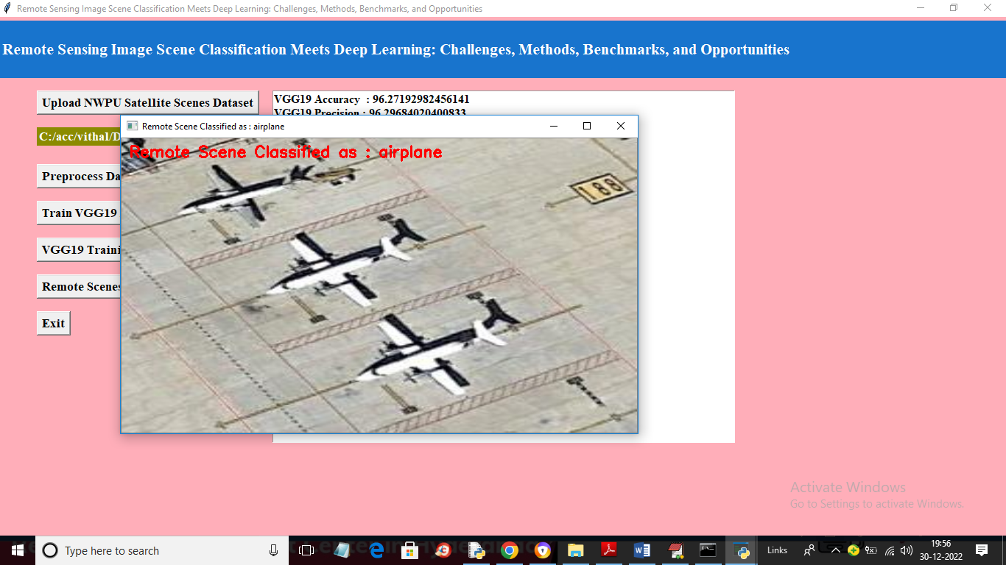

In above screen in red colour text image scenes classified as ‘airplane’ and similarly you can upload and test other images

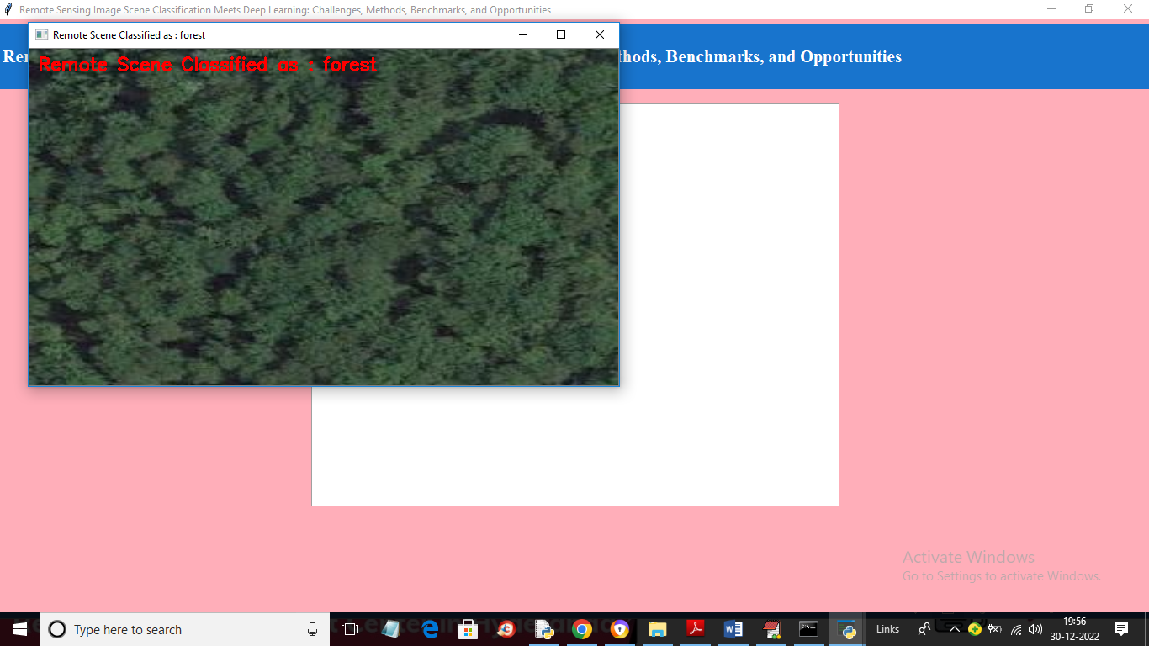

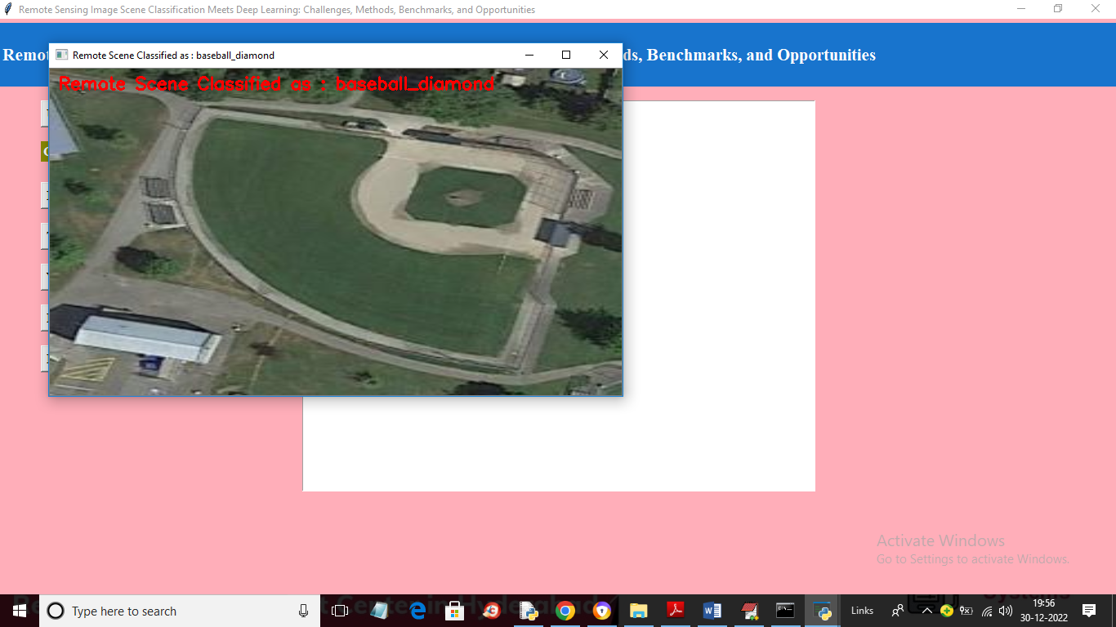

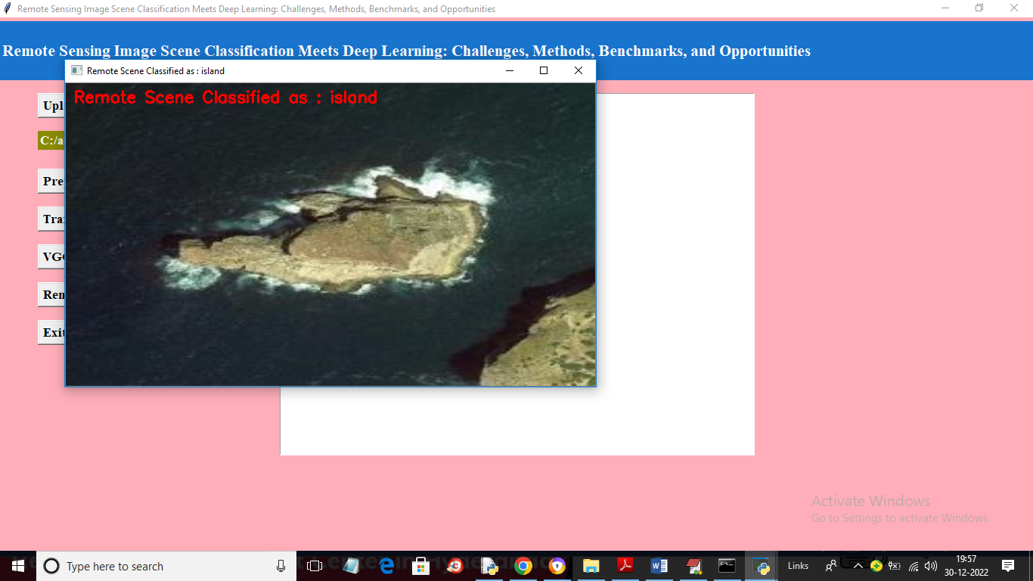

In below screen we are download one image satellite image from Google and then classifying with VGG19

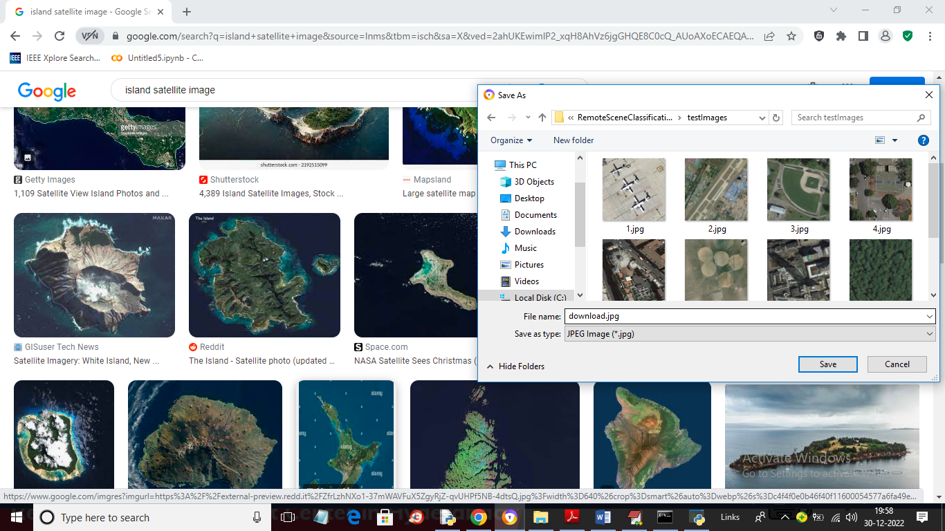

In above screen I am downloading Island scene image and then in below screen uploading same image

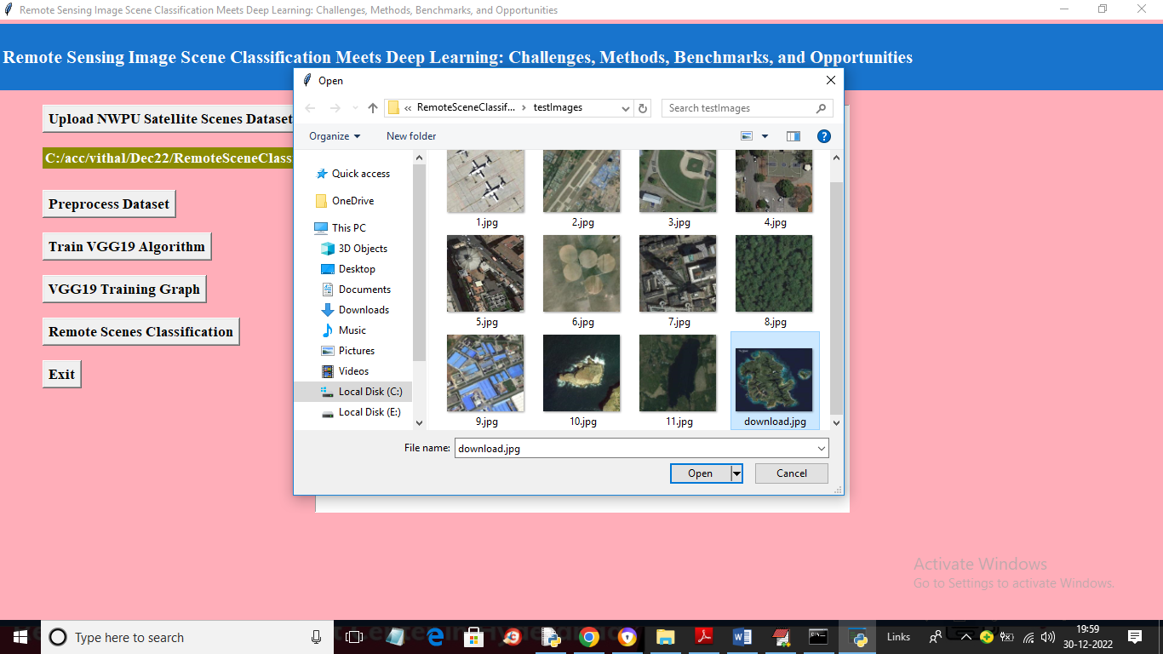

After uploading Google ‘download.jpg’ image will get below output

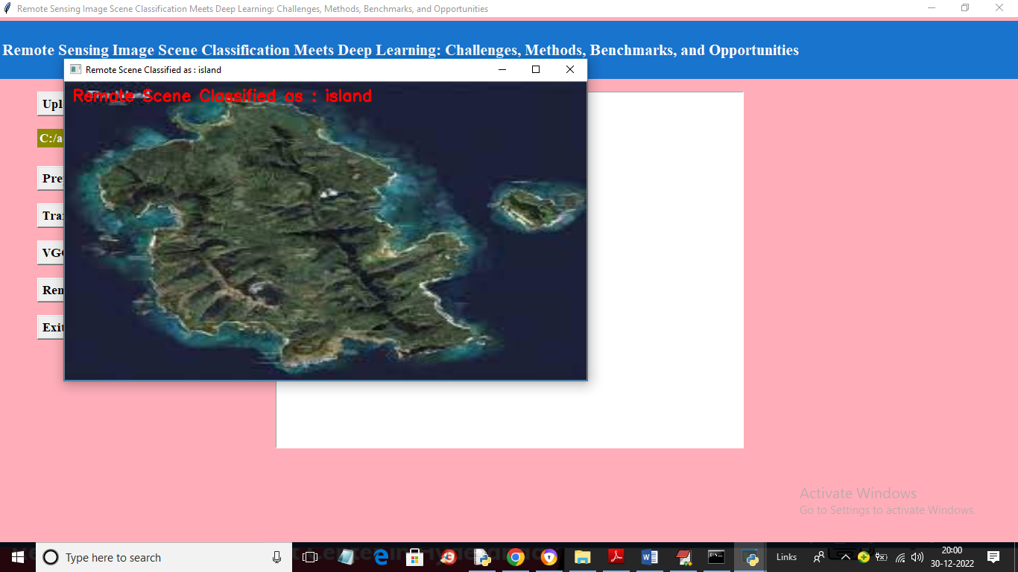

So VGG19 can classify any remote image with an accuracy of 95%